Chapter 19, Solution 81

(a) We set V₁ = 1 and short circuit the output port. The schematic is shown below. After simulation we obtain

y₁₁ = I₁ = 1.5, y₂₁ = I₂ = 3.5

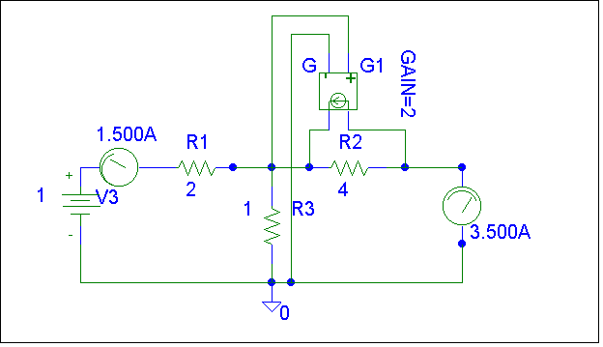
(b) We set V₂ = 1 and short-circuit the input port. The schematic is shown below. Upon simulating the circuit, we obtain

y₁₂ = I₁ = –0.5, y₂₂ = I₂ = 1.5

[Y] = S

